Exceptiion Handling : Chapter 6
Introduction :
The Exception Handling in Java is one of the powerful mechanism to handle the runtime errors so that normal flow of the application can be maintained.
Dictionary Meaning: Exception is an abnormal condition
In Java, an exception is an event that disrupts the normal flow of the program. It is an object which is thrown at runtime.

What is Exception Handling
Exception Handling is a mechanism to handle runtime errors such as ClassNotFoundException, IOException, SQLException, RemoteException, etc.

Advantage of Exception Handling
The core advantage of exception handling is to maintain the normal flow of the application. An exception normally disrupts the normal flow of the application that is why we use exception handling. Let's take a scenario:
- statement 1;
- statement 2;
- statement 3;
- statement 4;
- statement 5;//exception occurs
- statement 6;
- statement 7;
- statement 8;
- statement 9;
- statement 10;
Suppose there are 10 statements in your program and there occurs an exception at statement 5, the rest of the code will not be executed i.e. statement 6 to 10 will not be executed. If we perform exception handling, the rest of the statement will be executed. That is why we use exception handling in Java.

Hierarchy of Java Exception classes
The java.lang.Throwable class is the root class of Java Exception hierarchy which is inherited by two subclasses: Exception and Error. A hierarchy of Java Exception classes are given below:
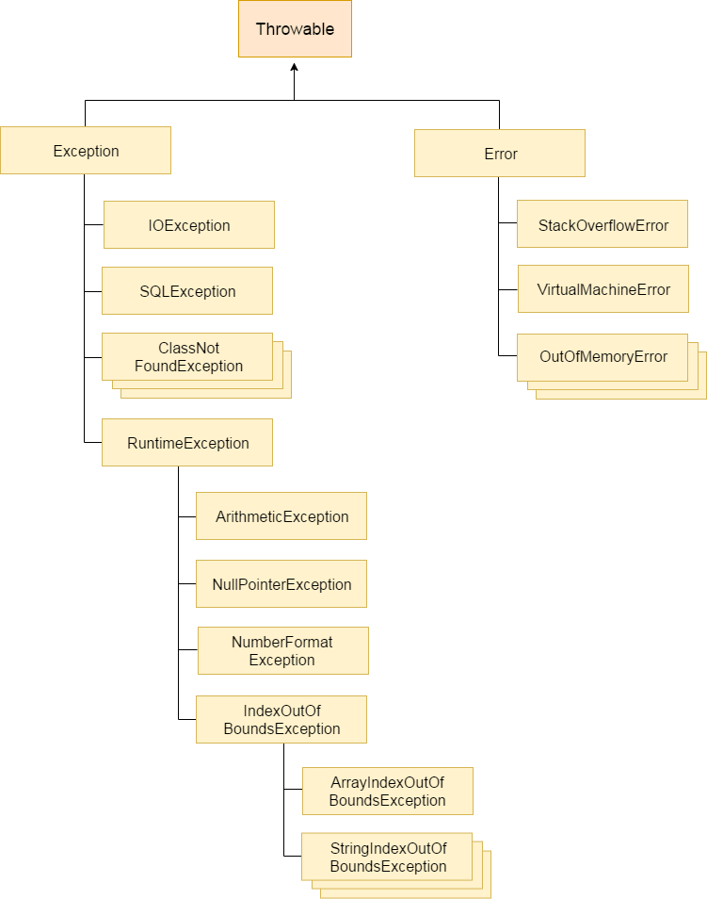

Types of Java Exceptions
There are mainly two types of exceptions: checked and unchecked. Here, an error is considered as the unchecked exception. According to Oracle, there are three types of exceptions:
- Checked Exception
- Unchecked Exception
- Error
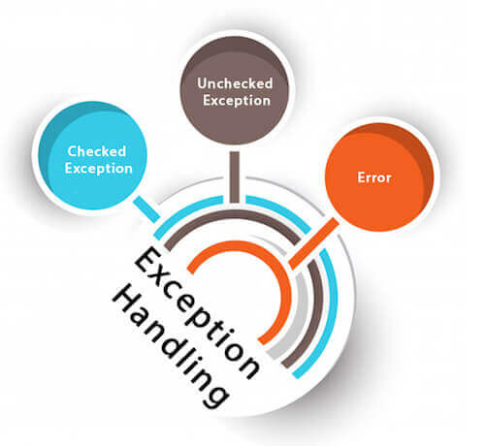

Difference between Checked and Unchecked Exceptions

1) Checked Exception
The classes which directly inherit Throwable class except RuntimeException and Error are known as checked exceptions e.g. IOException, SQLException etc. Checked exceptions are checked at compile-time.

2) Unchecked Exception
The classes which inherit RuntimeException are known as unchecked exceptions e.g. ArithmeticException, NullPointerException, ArrayIndexOutOfBoundsException etc. Unchecked exceptions are not checked at compile-time, but they are checked at runtime.

3) Error
Error is irrecoverable e.g. OutOfMemoryError, VirtualMachineError, AssertionError etc.

Java Exception Keywords
There are 5 keywords which are used in handling exceptions in Java.
Keyword | Description
try | The "try" keyword is used to specify a block where we should place exception code. The try block must be followed by either catch or finally. It means, we can't use try block alone.
catch | The "catch" block is used to handle the exception. It must be preceded by try block which means we can't use catch block alone. It can be followed by finally block later.
finally | The "finally" block is used to execute the important code of the program. It is executed whether an exception is handled or not.
throw | The "throw" keyword is used to throw an exception.
throws | The "throws" keyword is used to declare exceptions. It doesn't throw an exception. It specifies that there may occur an exception in the method. It is always used with method signature.

Java Exception Handling Example
Let's see an example of Java Exception Handling where we using a try-catch statement to handle the exception.
- public class JavaExceptionExample{
- public static void main(String args[]){
- try{
- //code that may raise exception
- int data=100/0;
- }catch(ArithmeticException e){System.out.println(e);}
- //rest code of the program
- System.out.println("rest of the code...");
- }
- }
- Output:
- Exception in thread main java.lang.ArithmeticException:/ by zero
- rest of the code...
- In the above example, 100/0 raises an ArithmeticException which is handled by a try-catch block.

Common Scenarios of Java Exceptions
There are given some scenarios where unchecked exceptions may occur. They are as follows:

1) A scenario where ArithmeticException occurs
If we divide any number by zero, there occurs an ArithmeticException.
- int a=50/0;//ArithmeticException

2) A scenario where NullPointerException occurs
If we have a null value in any variable, performing any operation on the variable throws a NullPointerException.
- String s=null;
- System.out.println(s.length());//NullPointerException

3) A scenario where NumberFormatException occurs
The wrong formatting of any value may occur NumberFormatException. Suppose I have a string variable that has characters, converting this variable into digit will occur NumberFormatException.
- String s="abc";
- int i=Integer.parseInt(s);//NumberFormatException

4) A scenario where ArrayIndexOutOfBoundsException occurs
If you are inserting any value in the wrong index, it would result in ArrayIndexOutOfBoundsException as shown below:
- int a[]=new int[5];
- a[10]=50; //ArrayIndexOutOfBoundsException

Java try block
Java try block is used to enclose the code that might throw an exception. It must be used within the method.
If an exception occurs at the particular statement of try block, the rest of the block code will not execute. So, it is recommended not to keeping the code in try block that will not throw an exception.
Java try block must be followed by either catch or finally block.

Syntax of Java try-catch
- try{
- //code that may throw an exception
- }catch(Exception_class_Name ref){}

Syntax of try-finally block
- try{
- //code that may throw an exception
- }finally{}

Java catch block
Java catch block is used to handle the Exception by declaring the type of exception within the parameter. The declared exception must be the parent class exception ( i.e., Exception) or the generated exception type. However, the good approach is to declare the generated type of exception.
The catch block must be used after the try block only. You can use multiple catch block with a single try block.
- public class TryCatchExample2 {

- public static void main(String[] args) {
- try
- {
- int data=50/0; //may throw exception
- }
- //handling the exception
- catch(ArithmeticException e)
- {
- System.out.println(e);
- }
- System.out.println("rest of the code");
- }

- }
- Output:
- java.lang.ArithmeticException: / by zero
- rest of the code
- Now, as displayed in the above example, the rest of the code is executed, i.e., the rest of the code statement is printed.

Be careful doing in this way
In this example, we also kept the code in a try block that will not throw an exception.
- public class TryCatchExample3 {

- public static void main(String[] args) {
- try
- {
- int data=50/0; //may throw exception
- // if exception occurs, the remaining statement will not exceute
- System.out.println("rest of the code");
- }
- // handling the exception
- catch(ArithmeticException e)
- {
- System.out.println(e);
- }

- }

- }
Output:
java.lang.ArithmeticException: / by zero
Here, we can see that if an exception occurs in the try block, the rest of the block code will not execute.
Let's see an example to resolve the exception in a catch block.
- public class TryCatchExample6 {

- public static void main(String[] args) {
- int i=50;
- int j=0;
- int data;
- try
- {
- data=i/j; //may throw exception
- }
- // handling the exception
- catch(Exception e)
- {
- // resolving the exception in catch block
- System.out.println(i/(j+2));
- }
- }
- }
Output:
25
Let's see an example to handle another unchecked exception.
- public class TryCatchExample9 {

- public static void main(String[] args) {
- try
- {
- int arr[]= {1,3,5,7};
- System.out.println(arr[10]); //may throw exception
- }
- // handling the array exception
- catch(ArrayIndexOutOfBoundsException e)
- {
- System.out.println(e);
- }
- System.out.println("rest of the code");
- }

- }
Output:
java.lang.ArrayIndexOutOfBoundsException: 10
rest of the code
Let's see an example to handle checked exception.
- import java.io.FileNotFoundException;
- import java.io.PrintWriter;

- public class TryCatchExample10 {

- public static void main(String[] args) {

- PrintWriter pw;
- try {
- pw = new PrintWriter("jtp.txt"); //may throw exception
- pw.println("saved");
- }
- // providing the checked exception handler
- catch (FileNotFoundException e) {

- System.out.println(e);
- }
- System.out.println("File saved successfully");
- }
- }
- Output:
- File saved successfully

Internal working of java try-catch block
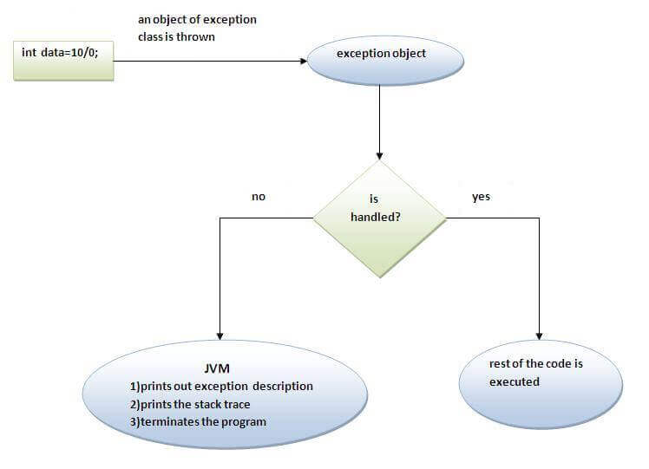
The JVM firstly checks whether the exception is handled or not. If exception is not handled, JVM provides a default exception handler that performs the following tasks:
- Prints out exception description.
- Prints the stack trace (Hierarchy of methods where the exception occurred).
- Causes the program to terminate.
But if exception is handled by the application programmer, normal flow of the application is maintained i.e. rest of the code is executed.

Java Multi-catch block
A try block can be followed by one or more catch blocks. Each catch block must contain a different exception handler. So, if you have to perform different tasks at the occurrence of different exceptions, use java multi-catch block.

Points to remember
- At a time only one exception occurs and at a time only one catch block is executed.
- All catch blocks must be ordered from most specific to most general, i.e. catch for ArithmeticException must come before catch for Exception.

Example 1
Let's see a simple example of java multi-catch block.
- public class MultipleCatchBlock1 {

- public static void main(String[] args) {

- try{
- int a[]=new int[5];
- a[5]=30/0;
- }
- catch(ArithmeticException e)
- {
- System.out.println("Arithmetic Exception occurs");
- }
- catch(ArrayIndexOutOfBoundsException e)
- {
- System.out.println("ArrayIndexOutOfBounds Exception occurs");
- }
- catch(Exception e)
- {
- System.out.println("Parent Exception occurs");
- }
- System.out.println("rest of the code");
- }
- }

Arithmetic Exception occurs
rest of the code

Example 2
- public class MultipleCatchBlock2 {

- public static void main(String[] args) {

- try{
- int a[]=new int[5];

- System.out.println(a[10]);
- }
- catch(ArithmeticException e)
- {
- System.out.println("Arithmetic Exception occurs");
- }
- catch(ArrayIndexOutOfBoundsException e)
- {
- System.out.println("ArrayIndexOutOfBounds Exception occurs");
- }
- catch(Exception e)
- {
- System.out.println("Parent Exception occurs");
- }
- System.out.println("rest of the code");
- }
- }
- Output:
- ArrayIndexOutOfBounds Exception occurs
- rest of the code

Java Nested try block
The try block within a try block is known as nested try block in java.

Why use nested try block
Sometimes a situation may arise where a part of a block may cause one error and the entire block itself may cause another error. In such cases, exception handlers have to be nested.

Syntax:
- ....
- try
- {
- statement 1;
- statement 2;
- try
- {
- statement 1;
- statement 2;
- }
- catch(Exception e)
- {
- }
- }
- catch(Exception e)
- {
- }
- ....

Java nested try example
Let's see a simple example of java nested try block.
- class Excep6{
- public static void main(String args[]){
- try{
- try{
- System.out.println("going to divide");
- int b =39/0;
- }catch(ArithmeticException e){System.out.println(e);}

- try{
- int a[]=new int[5];
- a[5]=4;
- }catch(ArrayIndexOutOfBoundsException e){System.out.println(e);}

- System.out.println("other statement);
- }catch(Exception e){System.out.println("handeled");}

- System.out.println("normal flow..");
- }
- }

Java finally block
Java finally block is a block that is used to execute important code such as closing connection, stream etc.
Java finally block is always executed whether exception is handled or not.
Java finally block follows try or catch block.
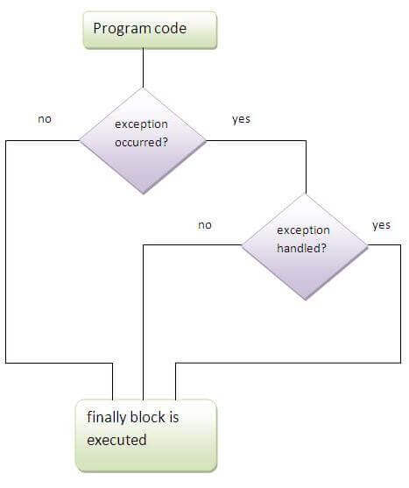

Why use java finally
- Finally block in java can be used to put "cleanup" code such as closing a file, closing connection etc.

Usage of Java finally
Let's see the different cases where java finally block can be used.

Case 1
Let's see the java finally example where exception doesn't occur.
- class TestFinallyBlock{
- public static void main(String args[]){
- try{
- int data=25/5;
- System.out.println(data);
- }
- catch(NullPointerException e){System.out.println(e);}
- finally{System.out.println("finally block is always executed");}
- System.out.println("rest of the code...");
- }
- }
- Output:5
- finally block is always executed
- rest of the code...

Difference between throw and throws in Java
There are many differences between throw and throws keywords. A list of differences between throw and throws are given below:
No. | throw | throws
1) | Java throw keyword is used to explicitly throw an exception. | Java throws keyword is used to declare an exception.
2) | Checked exception cannot be propagated using throw only. | Checked exception can be propagated with throws.
3) | Throw is followed by an instance. | Throws is followed by class.
4) | Throw is used within the method. | Throws is used with the method signature.
5) | You cannot throw multiple exceptions. | You can declare multiple exceptions e.g.  public void method()throws IOException,SQLException.

Java throw keyword
The Java throw keyword is used to explicitly throw an exception.
We can throw either checked or uncheked exception in java by throw keyword. The throw keyword is mainly used to throw custom exception. We will see custom exceptions later.
The syntax of java throw keyword is given below.
- throw exception;
Let's see the example of throw IOException.
- throw new IOException("sorry device error);

java throw keyword example
In this example, we have created the validate method that takes integer value as a parameter. If the age is less than 18, we are throwing the ArithmeticException otherwise print a message welcome to vote.
- public class TestThrow1{
- static void validate(int age){
- if(age<18)
- throw new ArithmeticException("not valid");
- else
- System.out.println("welcome to vote");
- }
- public static void main(String args[]){
- validate(13);
- System.out.println("rest of the code...");
- }
- }

Output:
Exception in thread main java.lang.ArithmeticException:not valid

Java throws keyword
The Java throws keyword is used to declare an exception. It gives an information to the programmer that there may occur an exception so it is better for the programmer to provide the exception handling code so that normal flow can be maintained.
Exception Handling is mainly used to handle the checked exceptions. If there occurs any unchecked exception such as NullPointerException, it is programmers fault that he is not performing check up before the code being used.

Syntax of java throws
- return_type method_name() throws exception_class_name{
- //method code
- }

Which exception should be declared
Ans) checked exception only, because:
- unchecked Exception: under your control so correct your code.
- error: beyond your control e.g. you are unable to do anything if there occurs VirtualMachineError or StackOverflowError.

Advantage of Java throws keyword
Now Checked Exception can be propagated (forwarded in call stack).
It provides information to the caller of the method about the exception.

Java throws example
Let's see the example of java throws clause which describes that checked exceptions can be propagated by throws keyword.
- import java.io.IOException;
- class Testthrows1{
- void m()throws IOException{
- throw new IOException("device error");//checked exception
- }
- void n()throws IOException{
- m();
- }
- void p(){
- try{
- n();
- }catch(Exception e){System.out.println("exception handled");}
- }
- public static void main(String args[]){
- Testthrows1 obj=new Testthrows1();
- obj.p();
- System.out.println("normal flow...");
- }
- }

Output:
exception handled
normal flow...

Java Custom Exception
If you are creating your own Exception that is known as custom exception or user-defined exception. Java custom exceptions are used to customize the exception according to user need.
By the help of custom exception, you can have your own exception and message.
Let's see a simple example of java custom exception.
- class InvalidAgeException extends Exception{
- InvalidAgeException(String s){
- super(s);
- }
- }
- class TestCustomException1{

- static void validate(int age)throws InvalidAgeException{
- if(age<18)
- throw new InvalidAgeException("not valid");
- else
- System.out.println("welcome to vote");
- }

- public static void main(String args[]){
- try{
- validate(13);
- }catch(Exception m){System.out.println("Exception occured: "+m);}

- System.out.println("rest of the code...");
- }
- }

