Critical Value Table for Kolmogorov Smirnov Test:
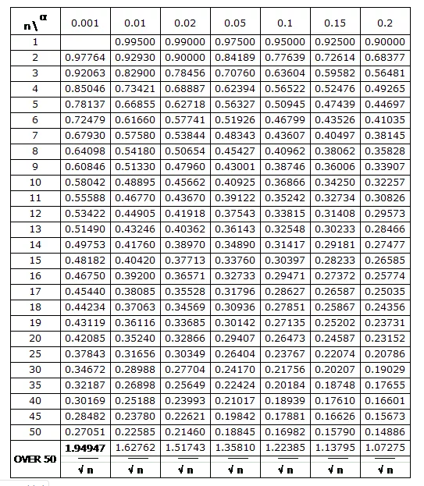

Critical Value Table for Chi-Square Test:
