what is HDL
hardware description lang
c,cpp how to manipulate or process data
gates
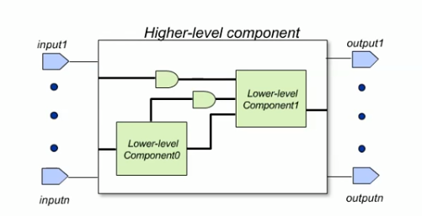
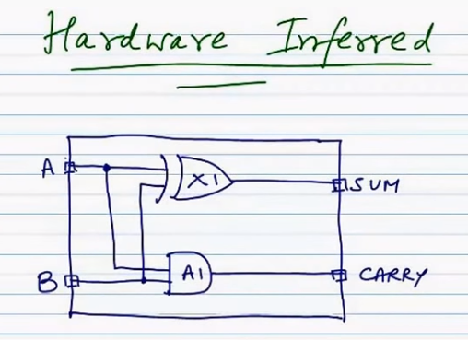
5 types design units
entity & data types
BIT, Boolean, std_logic
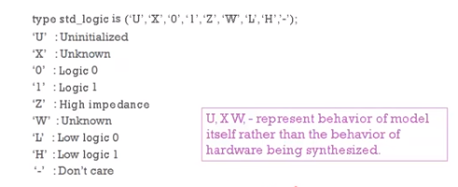
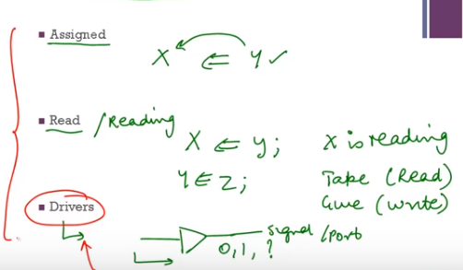

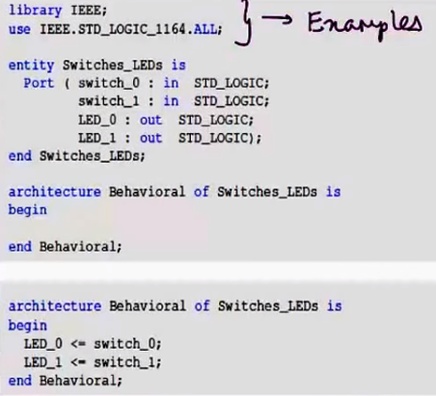
One entity can assigned with multiple architectures

architecture
configuration
package declaration
package body

3 types of modelling

Structural
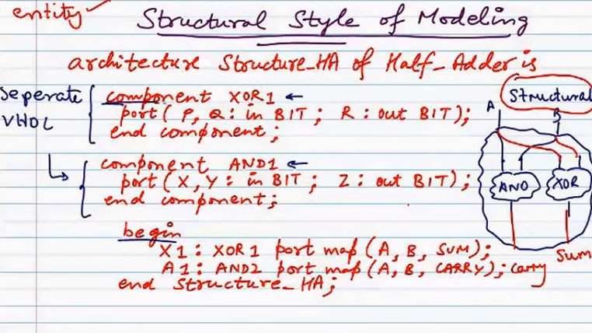
Data flow
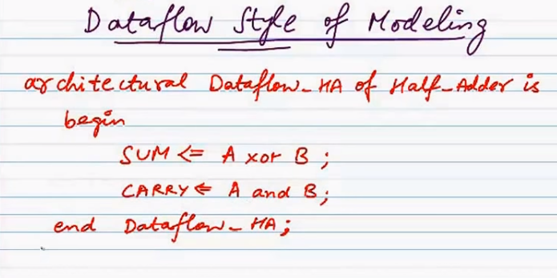
Behavioural

